ASSIGNMENT – 1

1. Data module Creation:

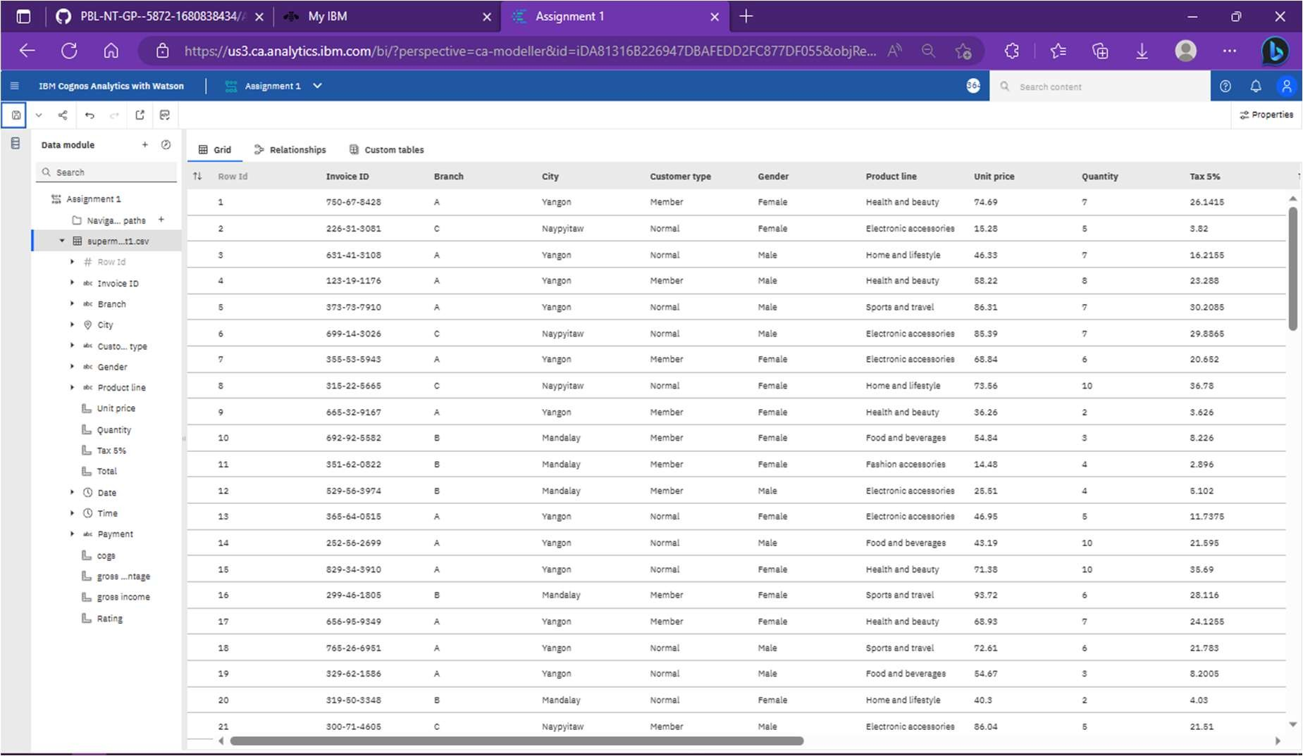

1. Deleting Unnecessary Column (Branch is deleted since we have cities):

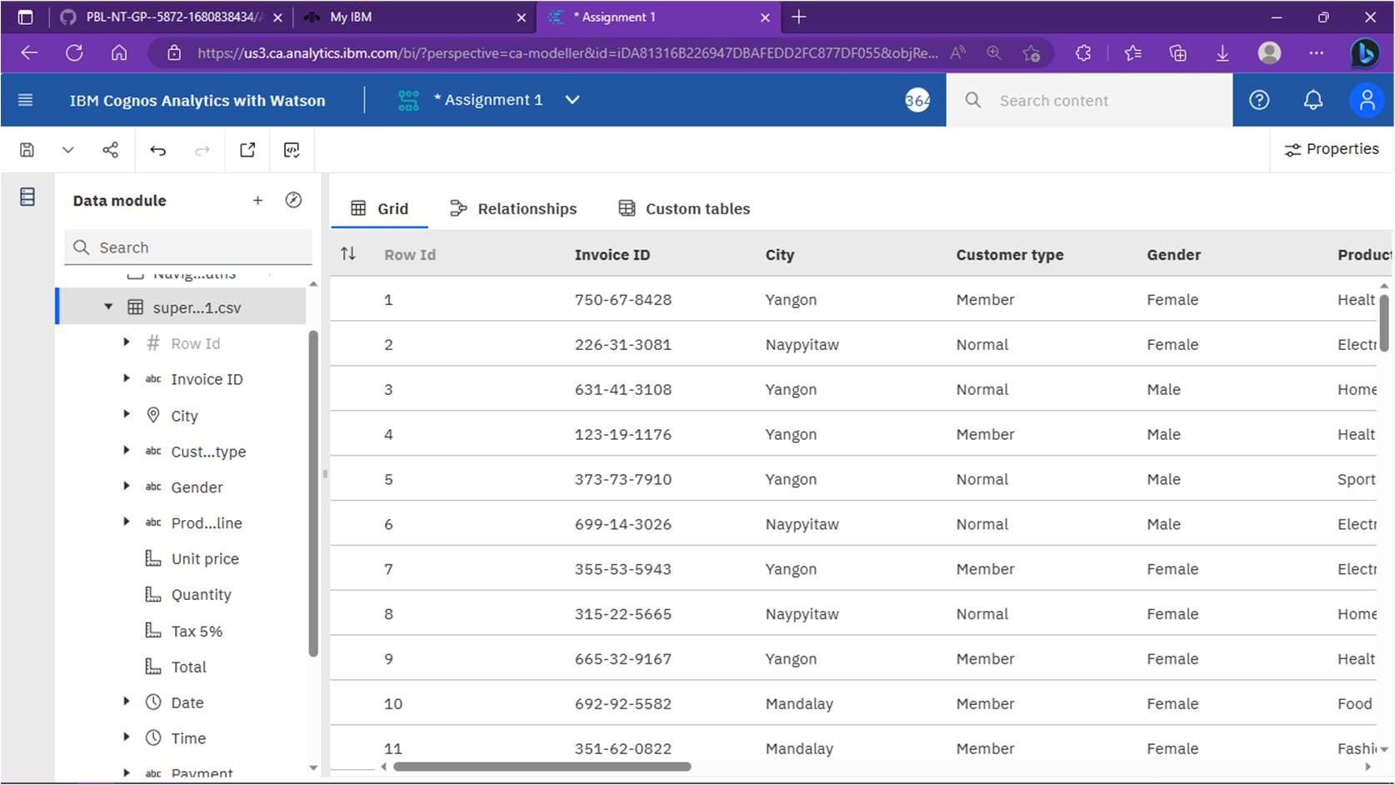

1. Dataset Visualization & Exploration:
2. Shows rating given by different gender in each city.

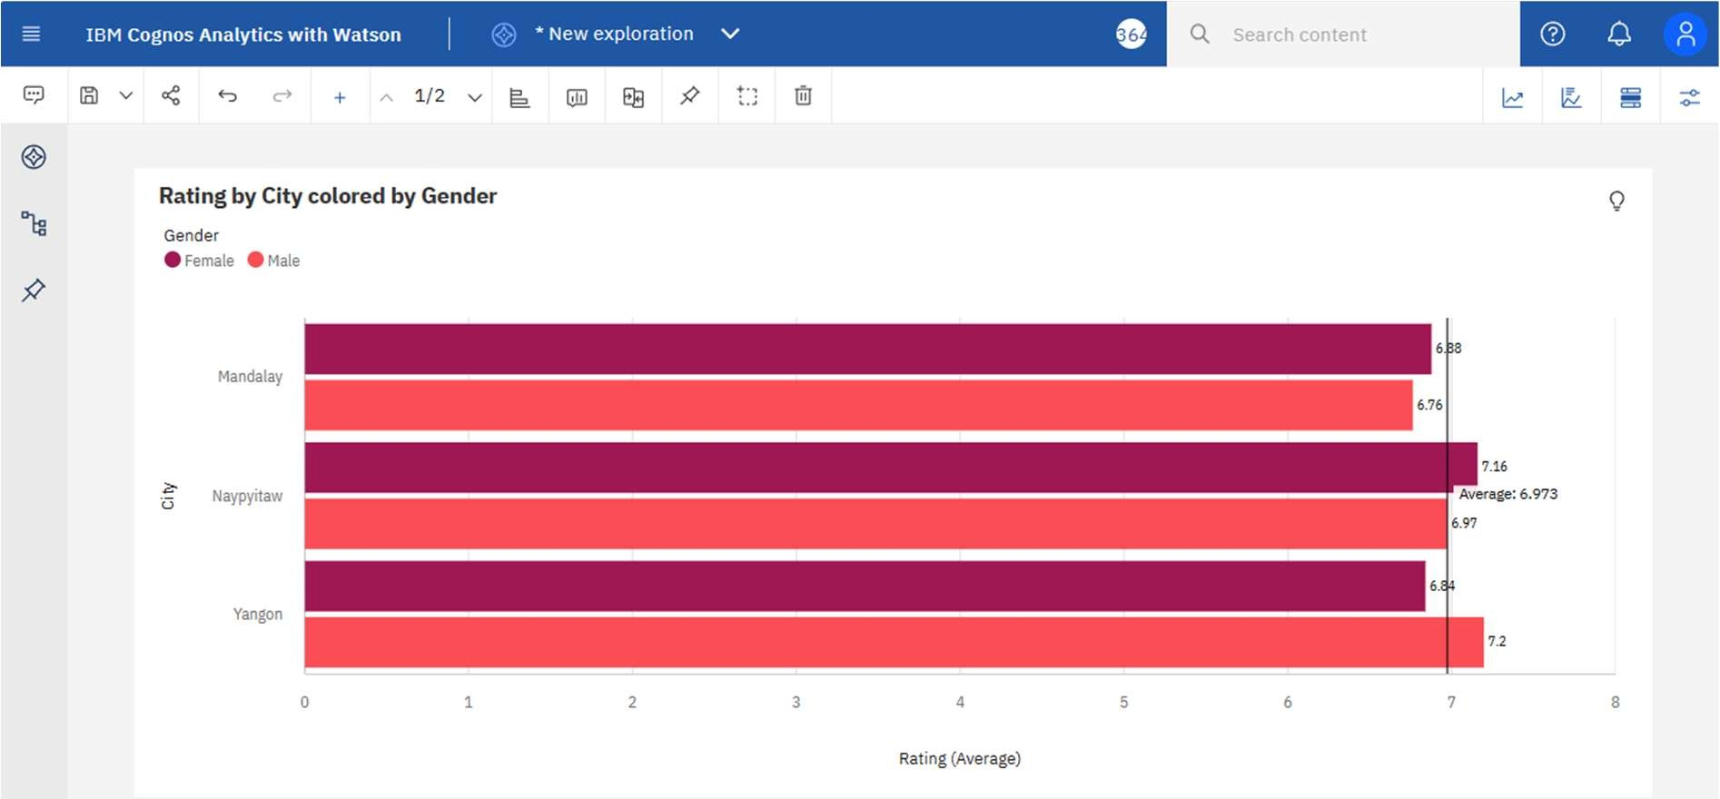

1. **gross income by Product line colored by Gender and Customer type**

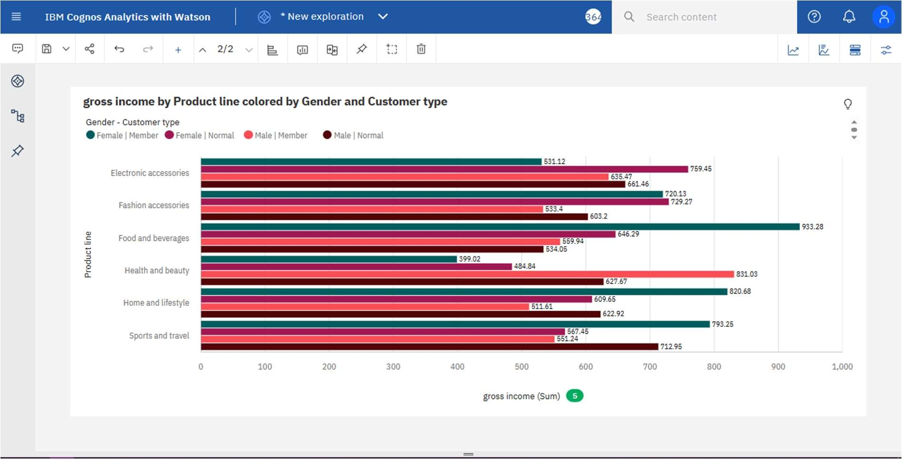

1. Comparison of gross income before and after 31th May.

